Identifying Network Devices

Instructions: Look at the network map below and identify the different devices by writing their names in the spaces provided. Then, briefly explain the role of each device in a network.

Network Map:

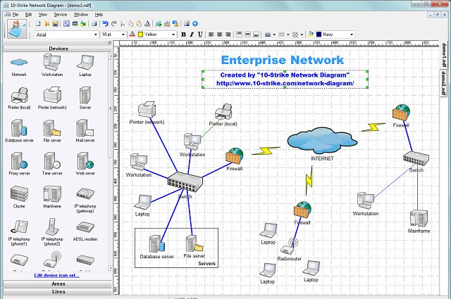

1. Device: _______________________

Role: __________________________

2. Device: _______________________

Role: __________________________

3. Device: _______________________

Role: __________________________

4. Device: _______________________

Role: __________________________

5. Device: _______________________

Role: __________________________

# Activity 1: Guided Practice

Instructions: Use the provided network components (router, modem, switch, access point) and place them in the proper location on the network map based on their roles. Use sticky notes or labels to indicate the name and role of each component.



# Activity 2: Independent Practice

Instructions: Create your own network map using the provided components (router, modem, switch, access point). Be creative and consider the specific needs and layout of your network. Label each component and indicate its role within the network.

